Configuring BRIO Connections for the Data Warehouse

Step 1: Welcome to BrioQuery
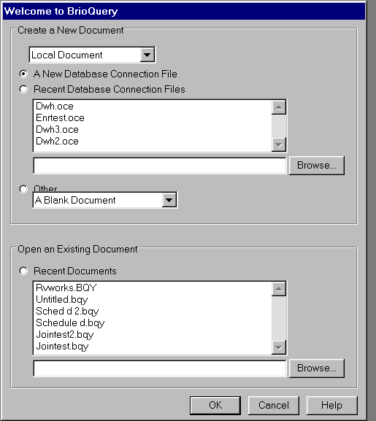
- Select A New Database Connection File
- Click OK

Step 2: Database Connection Wizard: Type of Connection
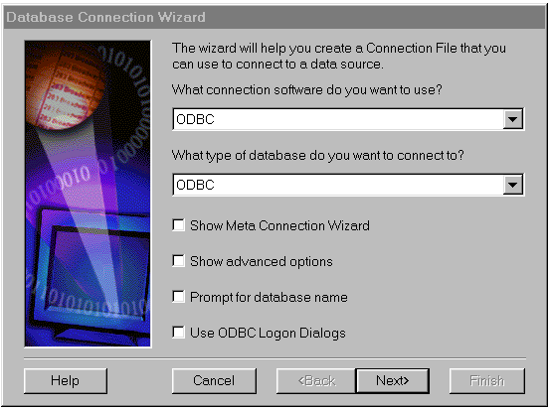
- Select ODBC for connection software
- Select ODBC for type of database
- Leave remaining boxes blank
- Click Next>

Step 3: Database Connection Wizard: Connect to the data source, enter user name….
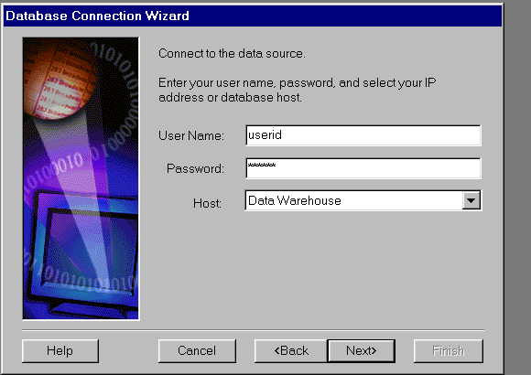
- Enter User Name as assigned
- Enter Password as assigned
- Select Data Warehouse as the Host
- Click Next>

Step 4: Database Connection Wizard: Press Finish…
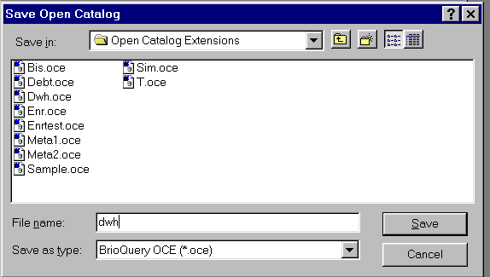
- Click Finish

Step 5: Do you want to save your OCE?
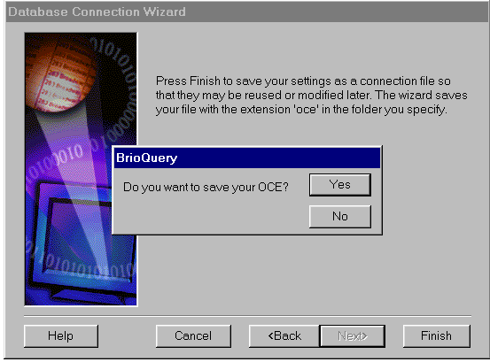
- Click Yes

Step 6: Save Open Catalog
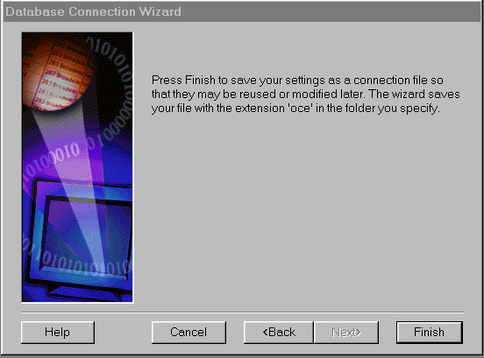
- Enter dwh as File Name
- Click Save

Upon completion of Step 6, BrioQuery will launch and you will be connected to the Data Warehouse.

