How to Create a Simple Focexec in WebFocus using Report Assistant

Log in to WebFocus via https://webfocus.ucop.edu.

Select the Financial domain under Repository. When you expand the Financial domain, you will see My Reports, Shared Reports and Reporting Objects.

From the Reporting Objects tab, right click on the desired table.

Select the specific table you would like to use. In many cases, and for this example, chose the Summary (All) for financial data from multiple or past cycles.

Right-click on the Summary (All) selection, and select Report Assistant from the menu that appears. You can also click on the Report Assistant icon in the toolbar.
You will be presented with a screen (below left) which shows all the fields in the table FIN_ALL_SUMMARY. Note that the report specification is all in one window with tabs for Field selection, Report headings, selection criteria and report options. Note that you can re-order the Field selection from the default list by alphabetic order into the Data Warehouse view order by clicking the tree icon next to the "Available fields:" label.

Select each field by double-clicking. Here we selected Location_1, Location_2, Account, Fund, Sub_Account and Finance_Amount.
You will see the fields appear in the "Sort by" column above. These fields will be used for ordering the data, as well as for aggregating it, if appropriate. Select carefully;
sort fields should not ordinarily be fields which have a large number of values.

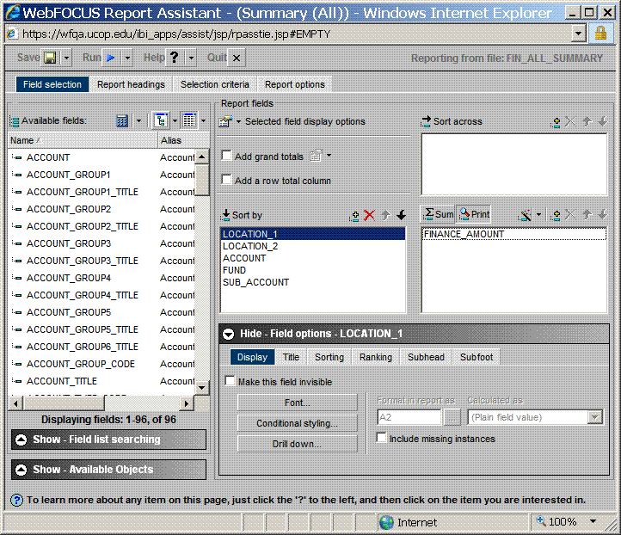

The Selection criteria tab -- This is where we limit our report specification by double-clicking each field. Here we selected Eff_Date, Account, Fund, Location_1, and Location_2.
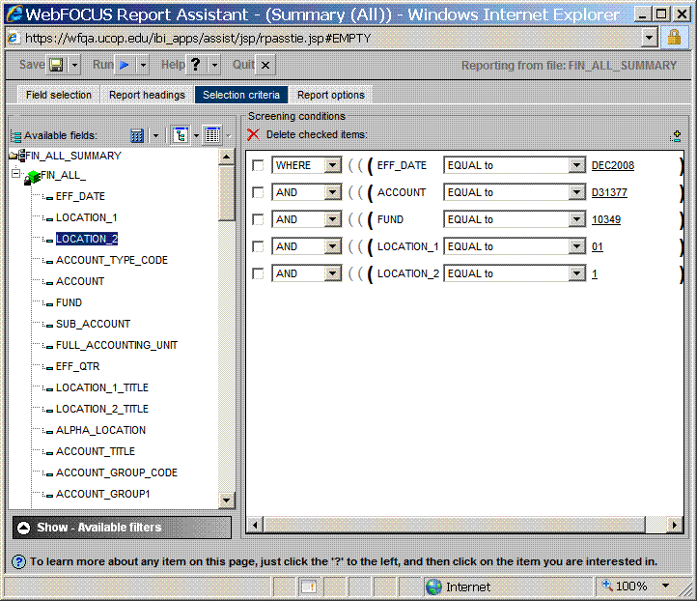

Test your report by using a recordlimit before running it against the entire table.
