Paid leave taken is included in the employee’s base pay.
If you want to report base pay, use CPS DOS codes AV, AW, AX, AM, HR, HD, and - for FTE and hours only, not
earnings – HY. Paid leave taken will be included in these DOS codes.
If including all types of pay, exclude CPS DOS Code “LV” as described below.
How to handle "LV" DOS codes if they must be included in a query
If you need to report the number of hours actually worked for a month, rather than the number of hours paid (including leave hours),
you will have to subtract leave hours from total hours for PPS locations.
Note that Terminal Vacation earnings records should have a CPS DOS Code of “BB” and therefore are never included in base pay.
The hours associated with Terminal Vacation should not be subtracted from the total hours worked; the amount paid is based on
vacation hours accrued, not taken.
Sample Records
Here are some typical distribution records which illustrate Leave Taken - those with Payment Category Code "L" represent
hours and FTE which should be subtracted from the total. Those with hours accrued (Payment Category A) should be
ignored (excluded) rather than subtracted.
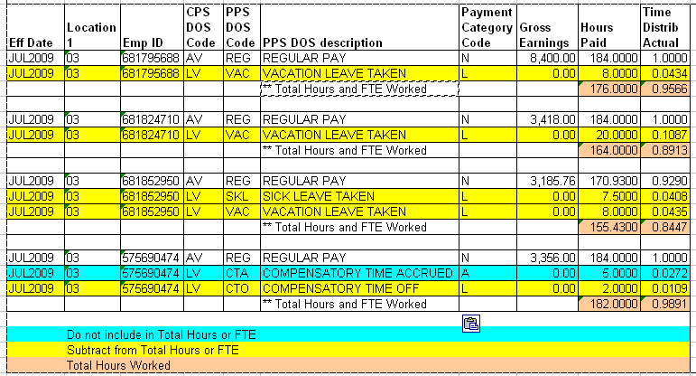

Instructions on Handling LV DOS Codes
Remember that the vast majority of queries will select the base pay DOS codes in order to determine that
the employee was active that month or to calculate the base salary or FTE. Queries do not need to be modified
if they are selecting only base pay (CPS DOS codes AV, AW, AX, AM, HR, HD, and - for FTE and hours only, not
earnings - HY) and there is no need to account for leave hours taken.
If you do need to exclude paid leave earnings and hours, here are some examples of defined fields which can be used to handle
them properly.
1) This is an example of a defined field named TOTALHRS which assumes that the LV DOS codes have been
included in the selection.
TOTALHRS excludes hours associated with leave (accrued or taken) from the total hours.
- TOTALHRS/P12.4C = IF DOS_CODE_CPS NE 'LV'
THEN HOURS_PAID_PAY_PER ELSE 0;
2) This is a defined field named LEAVEHRS which calculates the hours of leave taken so that those hours can be
subtracted from the total.
- LEAVEHRS/P12.4C = IF ((DOS_CODE_CPS EQ 'LV') AND (PAYMENT_CATEGORY_CD = 'L'))
THEN HOURS_PAID_PAY_PER ELSE 0;
3) Since the hours in LV records are positive, they must be subtracted if they have not been excluded from the initial
selection. HOURSWKD is a defined field which subtracts the leave hours taken from the total hours.
- HOURSWKD/P12.4C = TOTALHRS - LEAVEHRS;
4) FTE can be treated in the same way as Hours:
- TOTALFTE/P12.4C = IF DOS_CODE_CPS NE 'LV'
THEN TIME_DISTRIB_ACTUAL ELSE 0;
- LEAVEFTE/P12.4C = IF ((DOS_CODE_CPS EQ 'LV') AND (PAYMENT_CATEGORY_CD = 'L'))
THEN TIME_DISTRIB_ACTUAL ELSE 0;
- FTEWKD/P12.4C = TOTALFTE - LEAVEFTE;
5) Earnings should not be affected by the LV DOS codes for paid leave taken, since the earnings should be 0 in these records. If you choose to,
you can create defined fields related to earnings that are similar to the examples above for hours and FTE.
In some cases, you will find earnings that are NOT 0 in the LV records; I have found them to be earnings records where the
amounts were later adjusted, so there is one record with a positive amount and another with an offsetting negative amount.
DO NOT screen out either the credit or debit record if you are including LV DOS codes in your query.

